What’s on this week
Mon 15th May - 10.00 am Small Group @ Church
- 7.30 pm Women’s Small Group @ Sangy’s

Tue 16th May - 7.00 BSF @ Church
- Home Group @ Danny’s

Wed 17th May - 7.30 Men’s Small Group @ Wayne’s

Thur 18th May - 6.30 pm Music Practice @ Church

Fri 19th May - 6.00 pm AWAMA @ Church

Sun 21st May - 10.00 am SUNDAY SERVICE

Ministry Reminders
Date | Preaching | Sunday School | Welcoming | Morning Tea
14th May | Ps Greg | No Sunday School | Bill | Lindie
21st May | Andrew B. | Wilma | Wendy
28th May | Ps. Greg | Wendy | Peter
4th June | Ps. Greg | Ellen | Bill

2023 No.15  14/5/23 | Good morning and welcome to the Kelmscott Baptist Church. It’s great to have you with us. We hope you’ll be encouraged as you worship with us.  Good Giving Church  This year three particular facets of church life have been immensely encouraging:  - Small group engagement - We have well over 60% of our people in small groups. But better than that, people are significantly connecting with one another with care and prayer.  - Sunday morning greeting - On Sundays, when new people come, very often they are warmly engaged by our people.  - Giving – this year has seen a marked improvement in our giving. Giving and expenses by month this year has been as follows:  Giving Expenses  January $9,469 $6,918  February $9,991 $7,952  March $9,306 $8,096  April $6,388 $6,665  Though we dropped a bit last month, the overall trend is really positive. Thank you all for your commitment and generosity.  So far in 2023, so good. Yet, in many ways, this new season at KBC has only just begun. Let’s continue to encourage one another and so much more as we see the Lord’s return approaching (Hebrews 10:25).  Pastor Greg
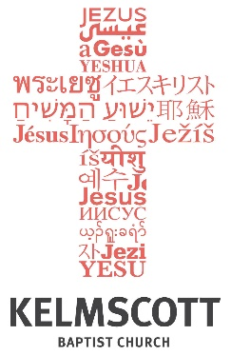

Glory to God
Hope to the World

.
Pastor
Greg Burgess
0406742009

We meet at
10.00 am Sunday
29 Third Ave
Kelmscott WA 6111

Website
www.kelmscottbaptist.org.au.o
rg.au

Creation & Blessing
The Importance of Image
Genesis 1:26-27

Introduction

Three qualities of the image of God:

- _______________________________________________

- ______________________ ________________________

- ______________________ ________________________

Three profound consequences of the image of God:

- _______________________________________________

- ______________________ ________________________

- ______________________ ________________________

BIG IDEA:

Small Group Questions:

1. Recount what it means to be made in the image of God.

2. Why do you think there is such ‘gender confusion’ being pushed in our culture? How does being made in God’s image speak to this issue?

3. Racism, historically understood, means to prefer or despise people solely on the basis of their race. How does being made in the image of God speak to this issue?

4. When does a person first begin to carry God’s image? How do we know, and what are the consequences?

