What’s on this week
Tue 06th Oct  Wed 07th Oct  Thur 08th Oct  Sun 11th Oct | - Ladies BSF @ Church – on break  - Home Group @ Gethin’s (Kelmscott) – on break  - Men’s Pod @ Reubens (Martin/Gosnells) - on break  - Home Group @ Bracegirdle’s (Champion Lakes) – on break  - 7.00 pm Worship Ministry Practice – t.b.a.  - 10.00 am Church Worship Service

 | Ministry Reminders
Date | Preacher | Church Bible Reading | Children’s Min. | Welcome | Morning Tea
4th Oct | Andrew B | Reuben - Mt 17:1-13 | N/A | Paul/Angie | Coffee – Phil/Jan  MT – Nau
11th Oct | Paul R. | Beula - Mt 17:14-27 | N/A | Bill/Hubert | Coffee – Phil/Jan  MT –
18th Oct. | Ps. Greg | Peter D. - Mt 18:1-14 | KC. Sangy? | Peter/Liam | Coffee – Paul +  MT –

KBC Bible School KBC General Group KBC Prayer Group
.   

Giving Options
There are four ways you can worship God by giving via KBC:
(1) the offering during our church services;
(2) debit or credit card at our terminal near the coffee machine;
(3) direct bank transfer to our account – BSB: 704 922 Ac #100021110
(4) Giveway https://kelmscott-baptist-church.giveway.org.au/igive-tithes-and-offerings

2026 No.40  04/10/26 | Good morning, and welcome to the Kelmscott Baptist Church. It’s great to have you here. We hope you’ll be encouraged as you worship with  Faith and Authority  Faith is not merely believing that Jesus can act; faith is trusting the authority of Jesus when circumstances appear to say otherwise.  Luke 8:22-56 contains four remarkable encounters with Jesus.  First, the disciples face a storm.  Then Jesus encounters a man possessed by demons.  Then a woman reaches out to Jesus because she has suffered from sickness for twelve years.  Finally, Jesus is confronted with something that appears beyond all human authority - death itself.  Storm. Demons. Disease. Death.  These four events seem very different, but Luke has placed them together for a reason.  They progressively reveal the authority of Jesus. And at the centre of these accounts is faith.  Jesus asks the disciples in verse 25: "Where is your faith?"  That question becomes a thread running through the entire passage. The issue isn't whether Jesus possesses authority.  The issue is whether you will trust His authority.  Andrew Bearfoot
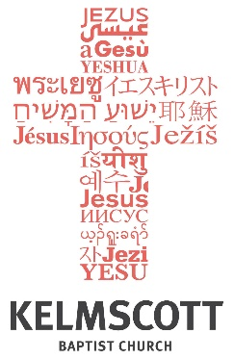

Glory to God
Hope to the World

.
Pastor
Greg Burgess
0401151192

We meet at
10.00 am Sunday.
29 Third Ave
Kelmscott WA 6111

Website
www.kelmscottbaptist.org.au.o
rg.au
Luke 8:22-56
Sermon Notes

